Figure 1. Samples of Larch, Pine, and Spruce in the field
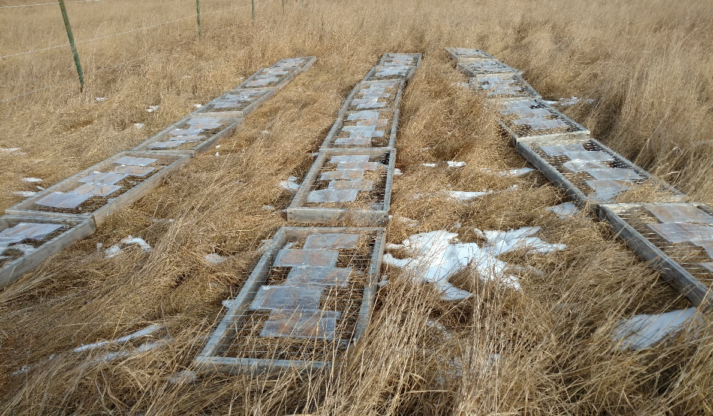
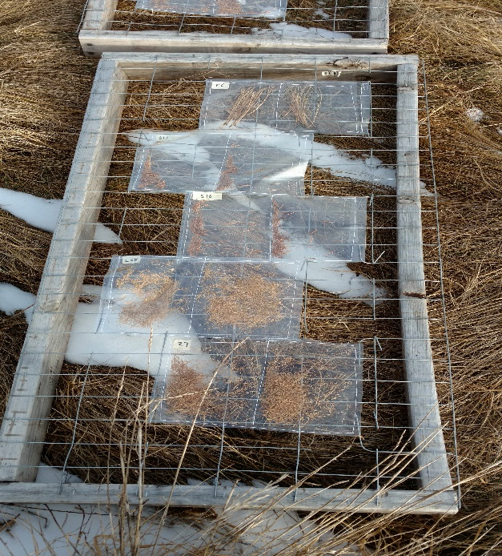

Samples of Larch, Spruce, and Pine needles were collected once they began senescing on the branch. Approximately 2g of Larch, Spruce, or Pine was placed in an envelope of either Mylar (admits UV radiation) or Teflon (attenuates UV radiation). Sample envelopes were connected to a wooden frame for either 90, 180, or 270 days. Once samples were collected, mass loss trials were performed followed by the ANKOM procedure. ANOVA tests were performed to determine significant differences between tree species and exposure time.

